**Answer Key**

1. **Set up the project in Visual Studio Code and GitHub utilizing npx and GitHub Copilot for code generation**

* 1. Set up a new React.js project with the default project structure and configuration using the following command:

**npx create-react-app@latest rec-app**

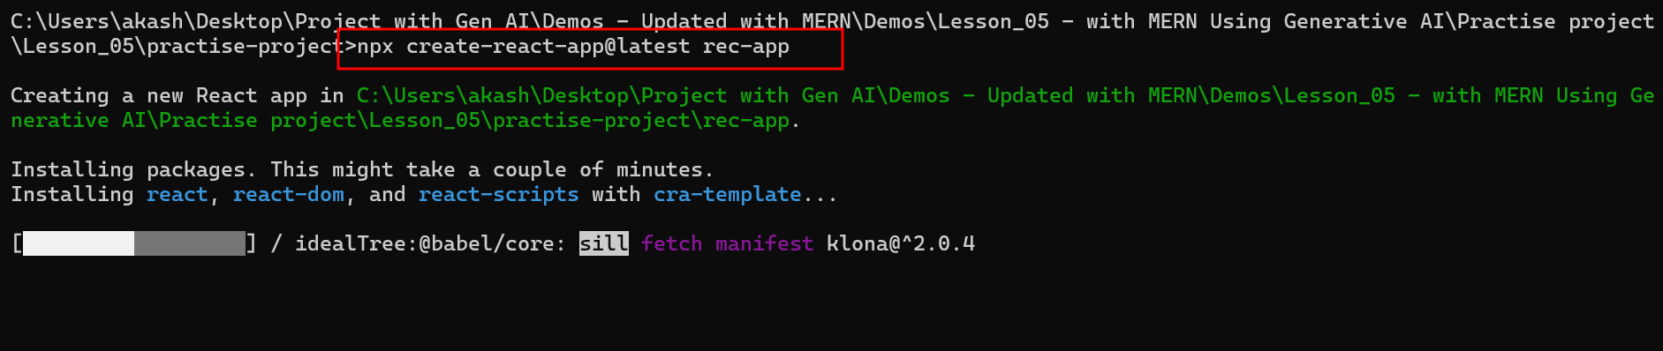

**Npx** : node package extension which help to create the take the help of external model js module without downloading explicitly and do the task for that module.

The React.js project is successfully created, showing the following after creation:

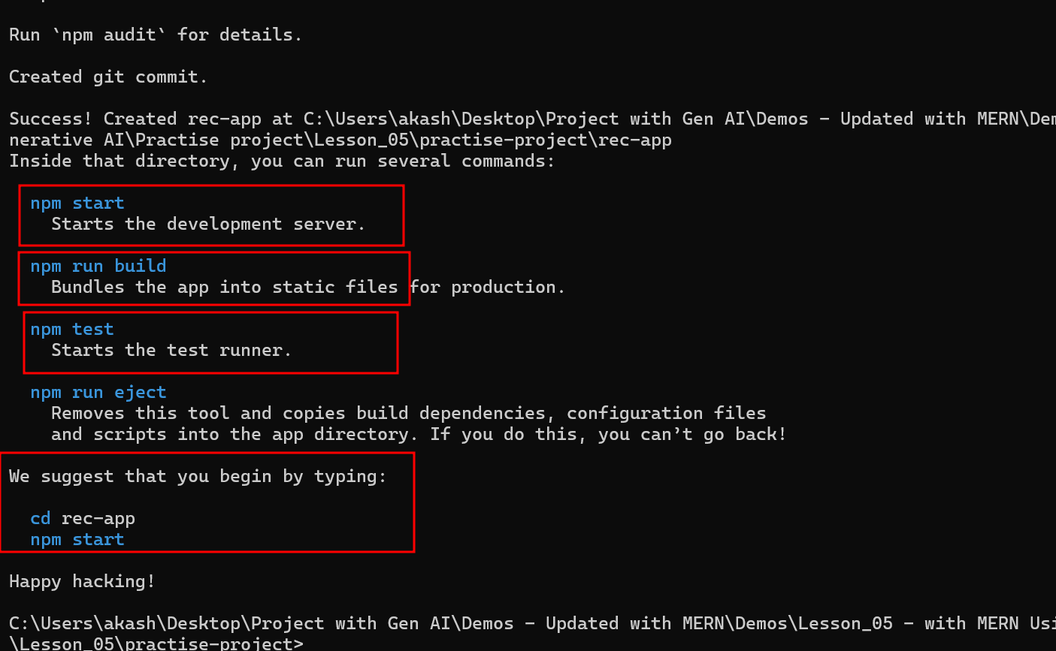

* 1. Execute the following command to navigate to the folder where it is created and to open that project in another instance of Visual Studio:

**cd .\rec-app\ it is use to move inside a project directory**

**code . it is one of the way to open the current directory in VSCode**

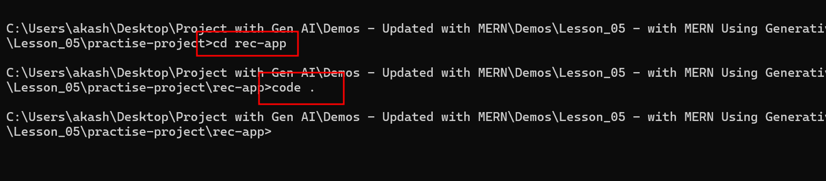

The basic React.js structure appears as follows:

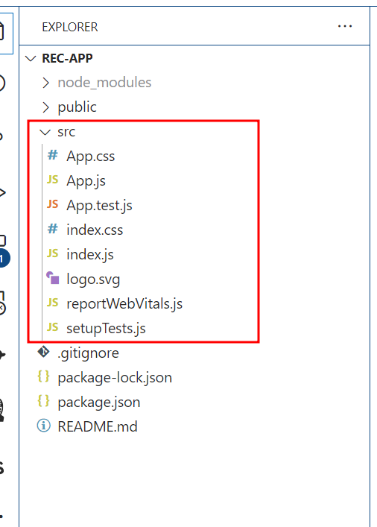

1. **Generate a basic user interface for recipe data using GitHub Copilot**
   1. Enhance the project by prompting GitHub Copilot to generate React.js code for a basic UI for the recipe app

**@workspace create a basic UI for recipe app**

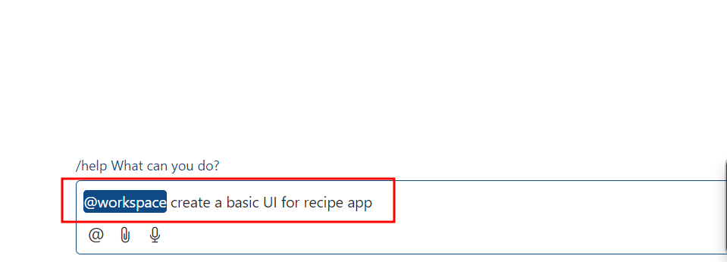

**Note:** Copy the contents of the generated script and paste them into the existing **src\App.js** file

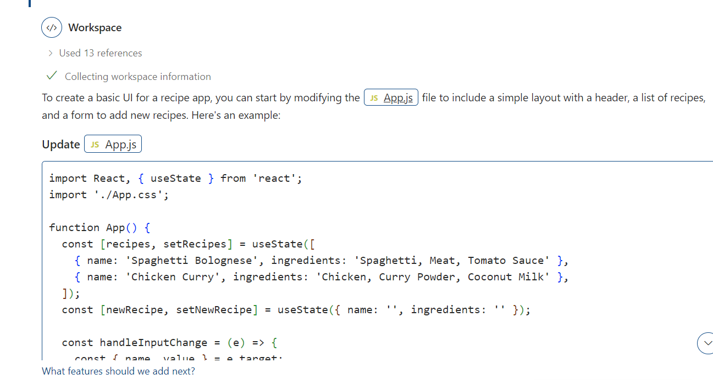

1. **Generate sample data using GitHub Copilot**
   1. Prompt GitHub Copilot to create sample data for the existing recipe app

**@wokspace create sample data for it**

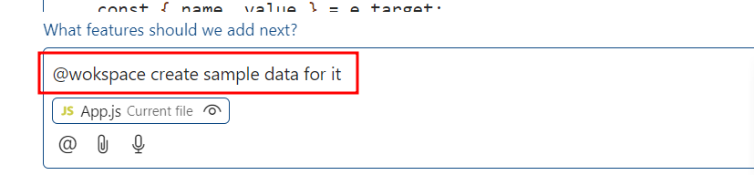

This generates the sample data for the recipe application. Create a file named **sampleData.js**, copy the sample data generated into this file, and save it in the

**rec-app\src** folder

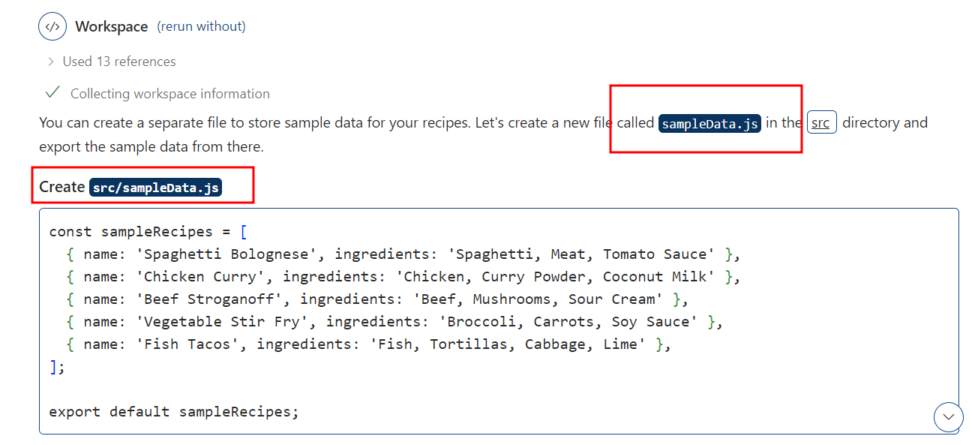

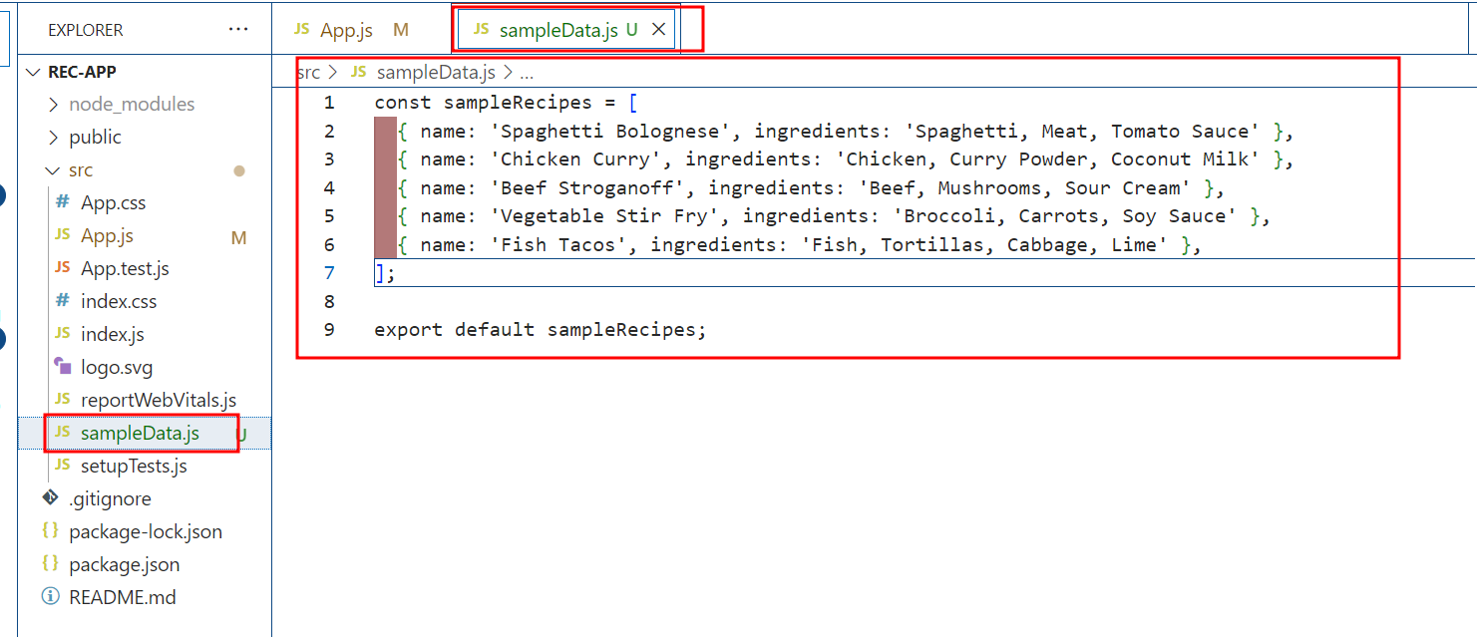

* 1. Open **App.js** and import the newly created **recipe.js** by adding the following script:

**import sampleRecipes from './sampleData';**

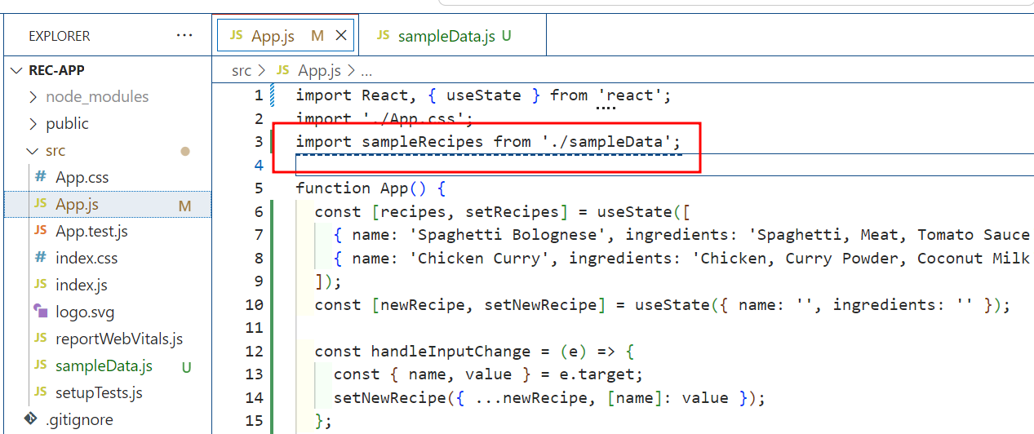

1. **Generate React code to display the recipes using the user interface**
   1. Prompt GitHub Copilot to generate code to display the recipe data using the   
      user interface

**show these recipes in UI**

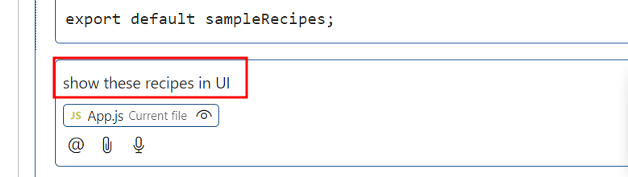

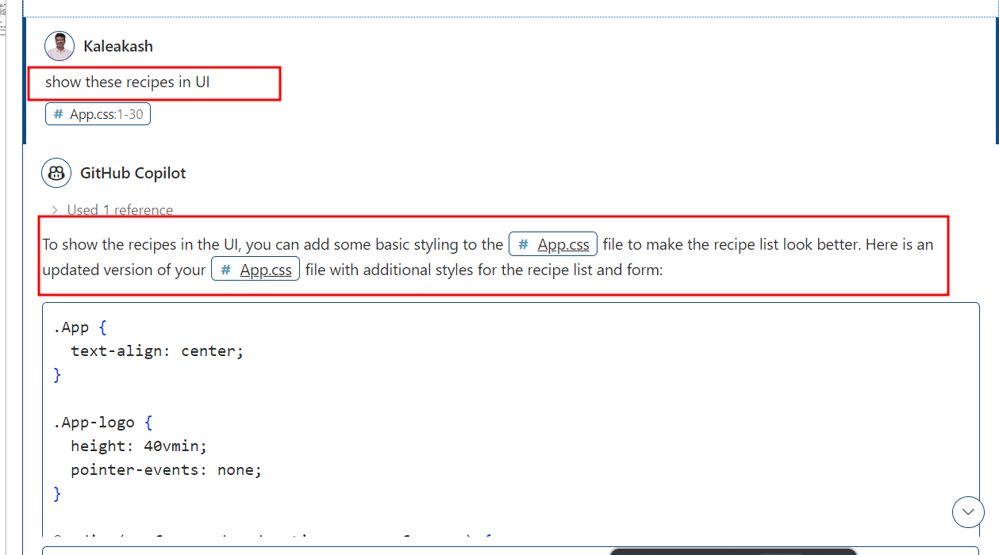

Copy basic CSS rules in App.css file

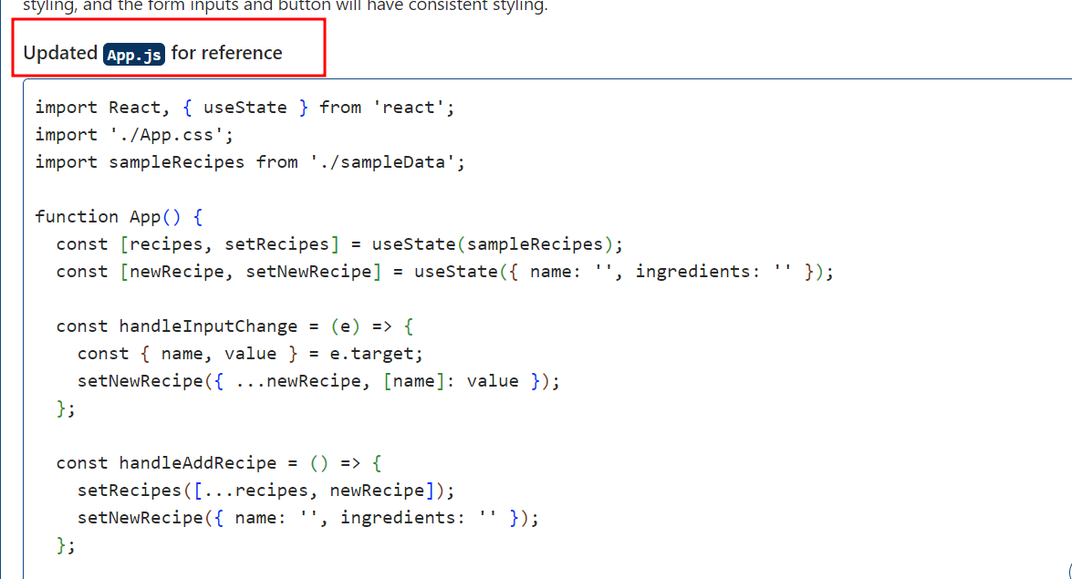

Update new generated content in App.js file

* 1. Run the react project after updating App.js

**npm start**



The following message will be displayed after successful execution:

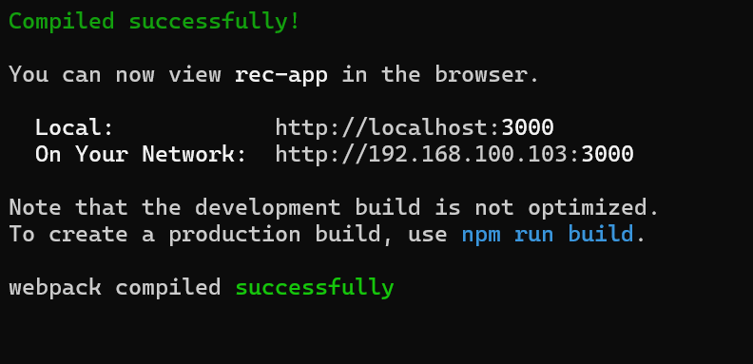

The output will appear as follows:

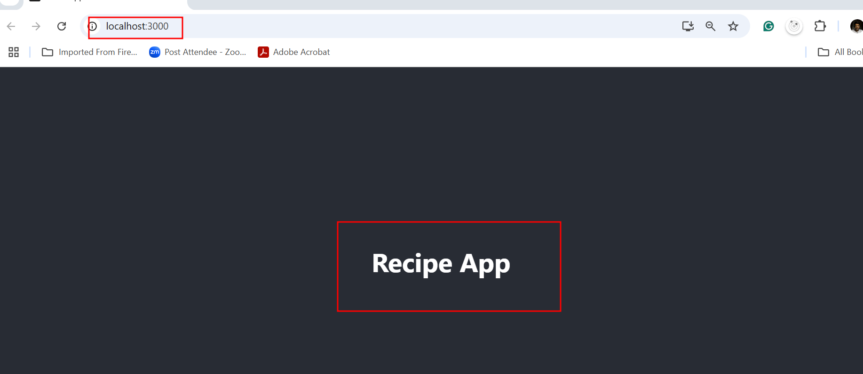

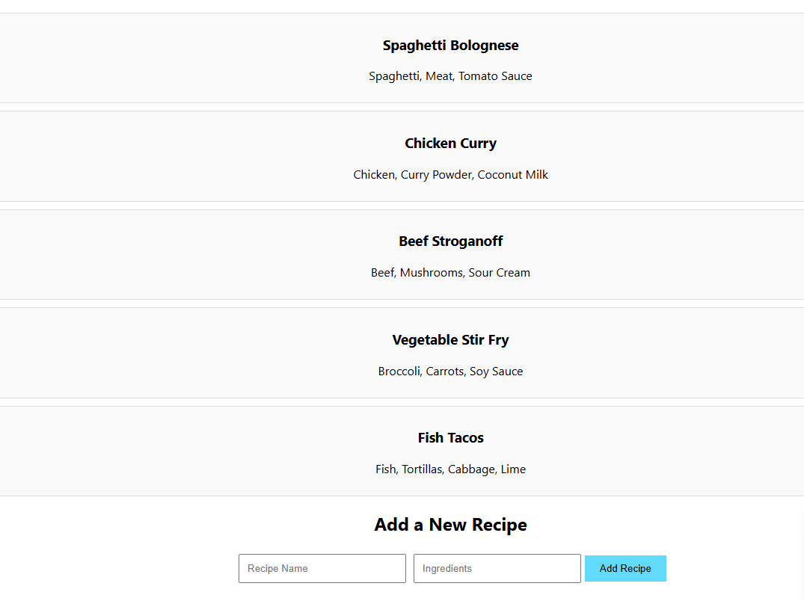

1. **Generate a React code to add more recipes to the recipe app**
   1. Improve the recipe app by adding more recipes using GitHub Copilot prompts

**@workspace add more recipes with images**

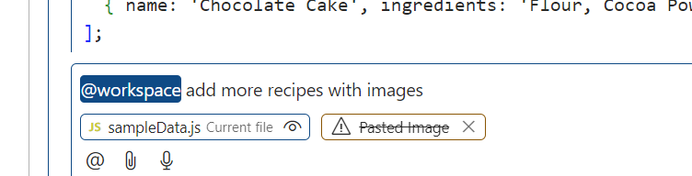

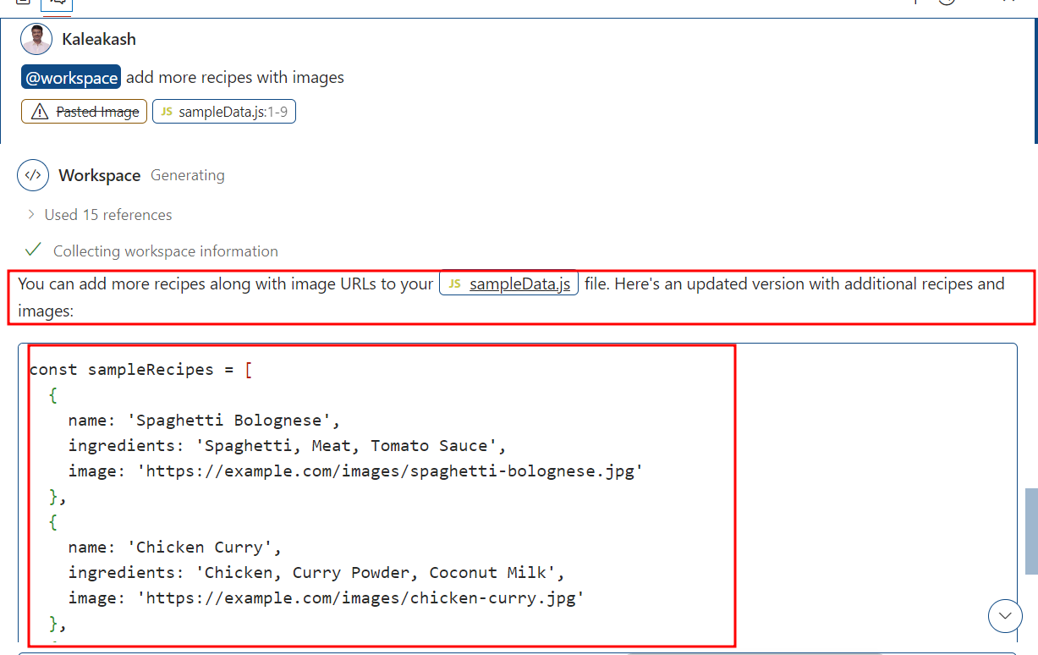

The following React.js code will be generated by GitHub Copilot:

**Update the sampleData.js file code**

**Show new update these recipes in UI with images**

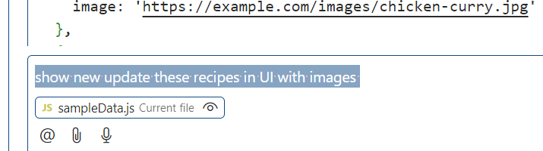

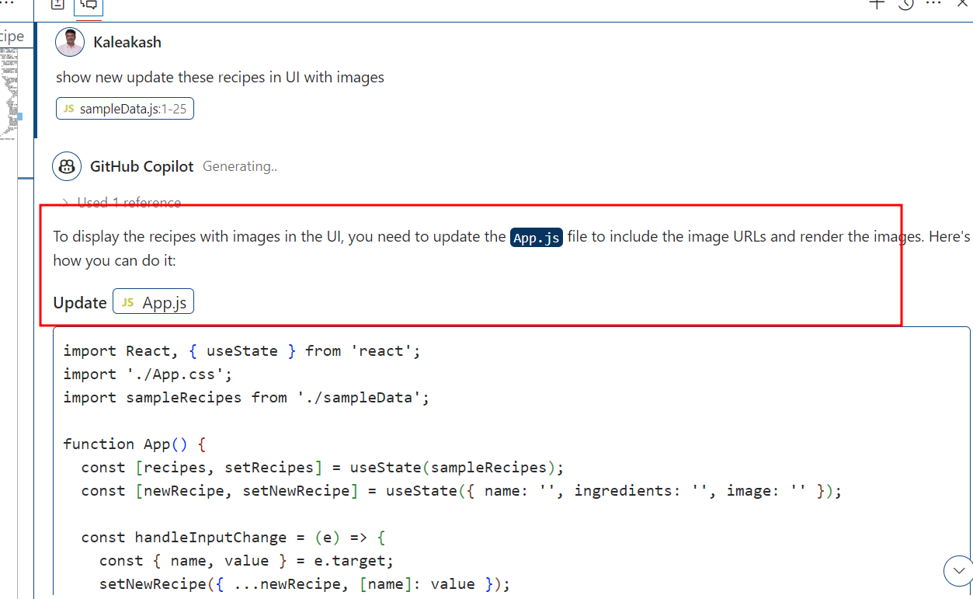

Update the new changes in App.js file as well as App.css file

The final code of all files

Execute the React project using **npm start** after updating the recipe.js file. The output will appear as follows:

1. **Create the Recipe Detail Component to display detailed information about each recipe**
   1. Prompt GitHub Copilot to generate a React code for displaying details of each recipe

**show it in card format in UI, on click of card it should load the details**

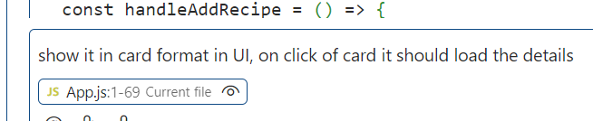

**Note:** Copy the contents of the generated script and paste them into the existing **src\App.js** file

After updating App.js file, execute the React project using **npm start**. The output will appear as follows:

**Apply new updated in App.js and App.css file**

Now check updated output

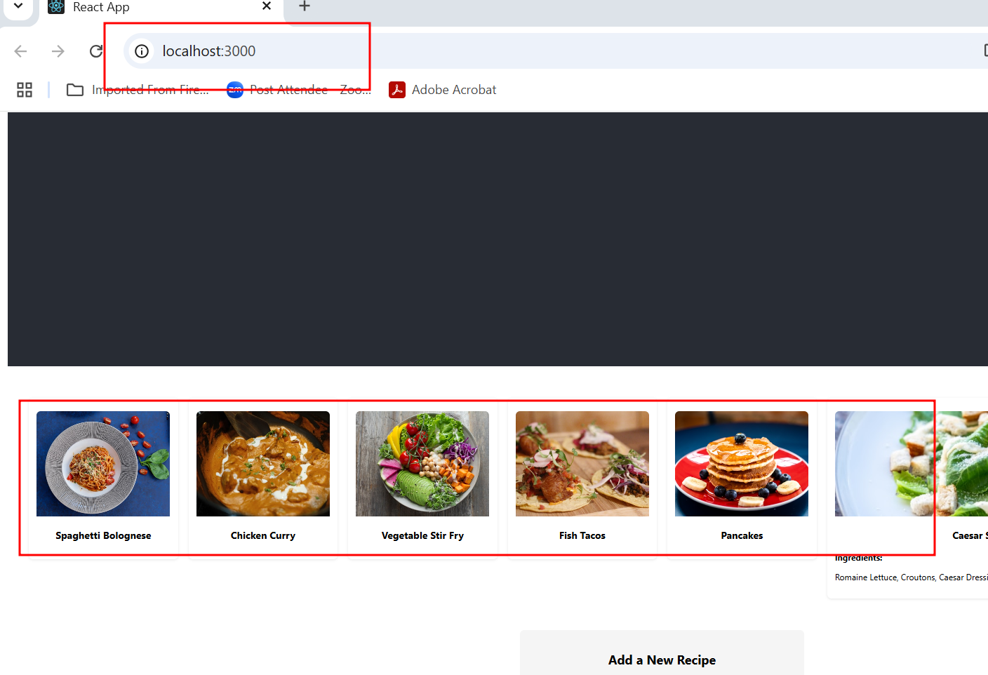

When you click on particular image you get that image details

1. **Implement search functionality to enable users to search for   
   specific recipes**

7.1 Design a search feature by prompting GitHub Copilot

**@workspace implement search recipe functionality**

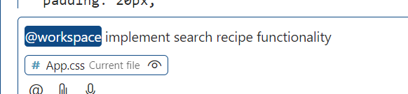

After get new code update the code in App.js and App.css file

The output will appear as follows:

